AirBattle – eyal magen

Intro:

This project was created by me in the end of 2016. I was just started my first job and wanted a project which is both fun and will help me get better on my free time.

It was created with pygame.

After a while I learned to develop games using unity which is much easier, and the result is much better. The home screen design in this game was created with power point which is lame…but the missiles are cool. You should play it! it’s fun!

How to play:

1. Git clone <https://github.com/eyalmagen/AirBattle.git>
2. In cmd: python run.py

Screenshots and explanation:

Home screen:

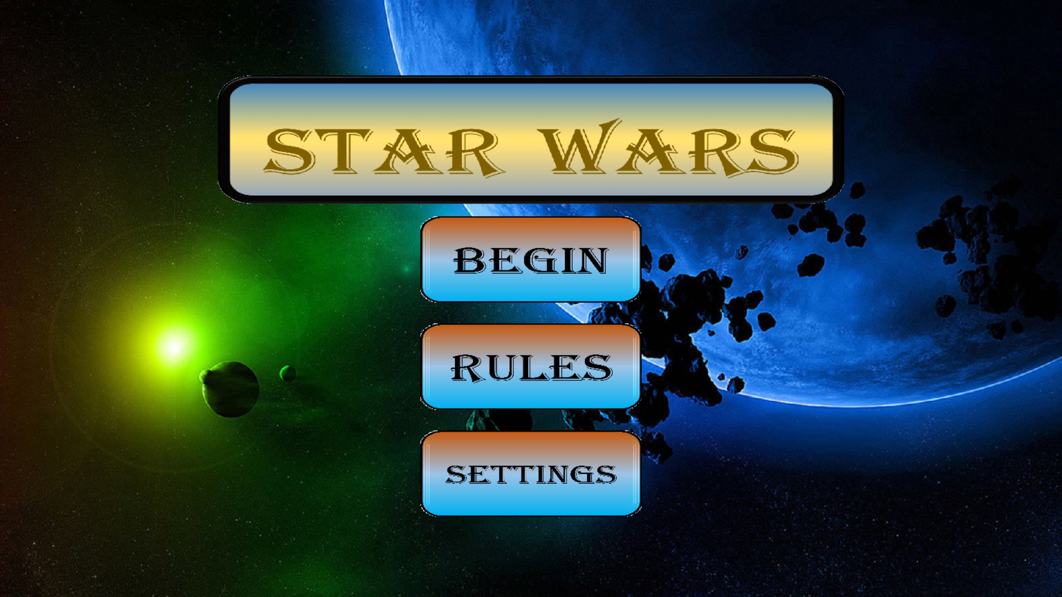

Rules will get you here:

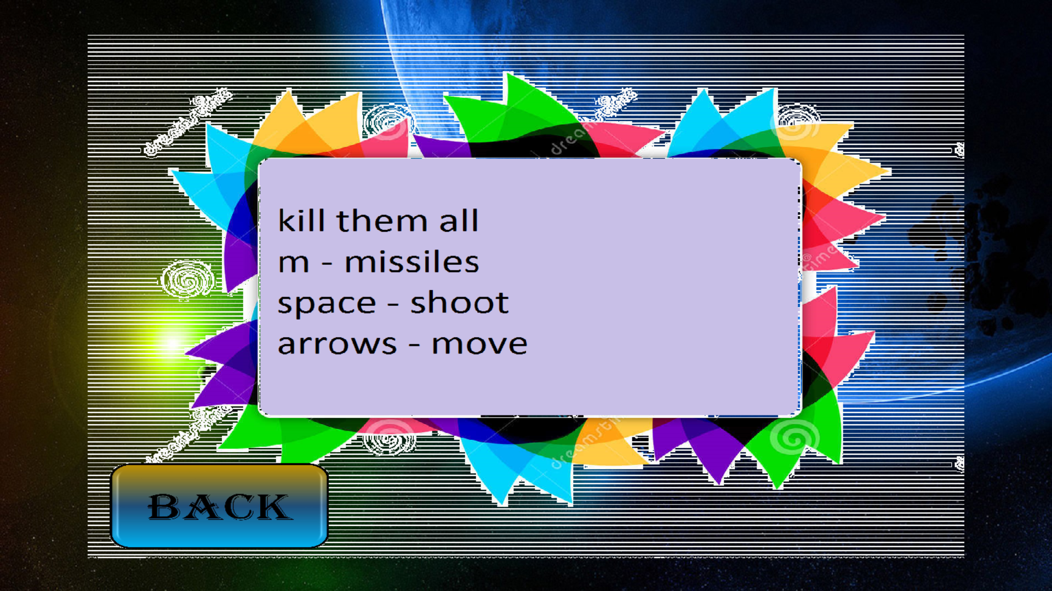

Press back and then begin, youll get here:

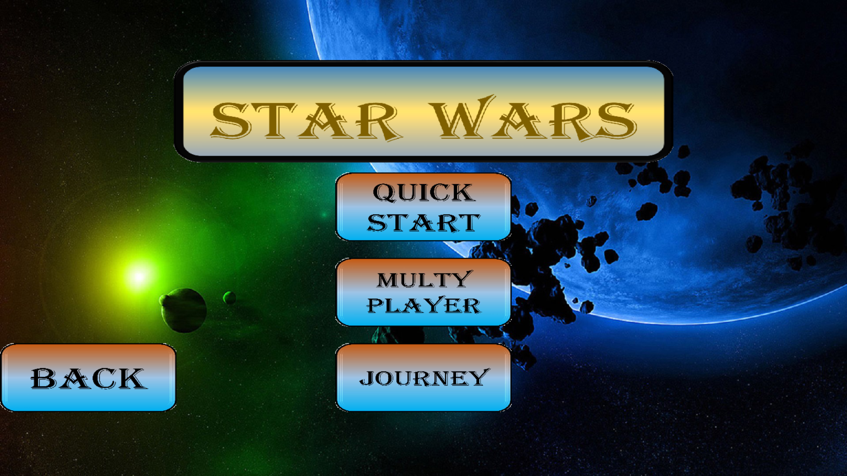

Press quick start or journey (for levels).

Multy player does not exist.

This is how the actual game looks like:

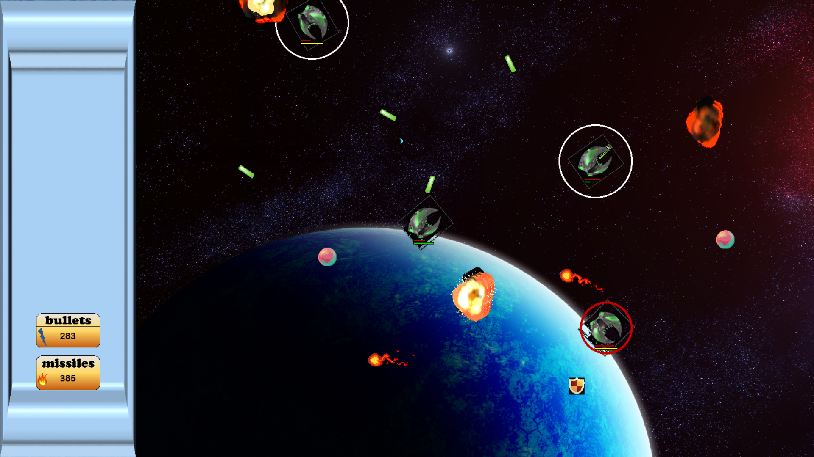

* You play as the ship with the red circle.
* There are things appearing on the screen like life, laser power or shiled(when shielded nothing can hurt you.
* You can shoot non-stoop, there is reload time.
* The missiles are changing their direction to hit the ship it has the most chance of hitting.
* If you hit one wall you come out of the other one.
* Press P to pause the game and w to win it automatically